Parallel Programming Exercise 4 – 6

Author: | 李昌樺 (R11525006@ntu.edu.tw)
Student ID | R11525006
Department | Engineering Science and Ocean Engineering
(If you and your team member contribute equally, you can use (co-first author), after each name.)

Problem and Proposed Approach
(Brief your problem, and give your idea or concept of how you design your program.)
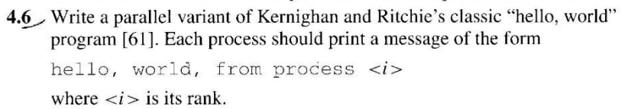
- 初始化MPI環境
- 得到Processes的數量與名字和個別的id
- 每個processor都輸出 Hello world! 字樣
- 結束MPI環境

Conclusion and Discussion
(Discuss the following issues of your program)
- What is the speedup respect to the number of processors used?
每個處理器都會執行同一件事speedup不應該上升或下降

Appendix(optional):
(If something else you want to append in this file, like picture of life game)
